Assignment 1

Kaustubh Sanjay Patil
University of the Potomac
COMP401: Database Organization I
Professor: Privat Epee Thonga
June 4, 2023

SQL Queries and Analysis

1: Data Setup & Initialization
SQL Script:
CREATE TABLE students (id INTEGER PRIMARY KEY, name TEXT);
CREATE TABLE grades (student_id INTEGER, subject TEXT, score INTEGER);

INSERT INTO students (id, name) VALUES (1, 'Kaustubh'), (2, 'Ram'), (3, 'Jay'), (4, 'Mansi'), (5, 'Mitali'), (6, 'Sanket'), (7, 'Mayue'), (8, 'Priyanshi'), (9, 'Om'), (10, 'Harsh');

INSERT INTO grades VALUES (1, 'Math', 90), (2, 'Math', 85), (3, 'Science', 92), (4, 'Science', 78), (5, 'Math', 88), (6, 'History', 95), (7, 'History', 82), (8, 'Math', 79), (9, 'Science', 87), (10, 'History', 91);
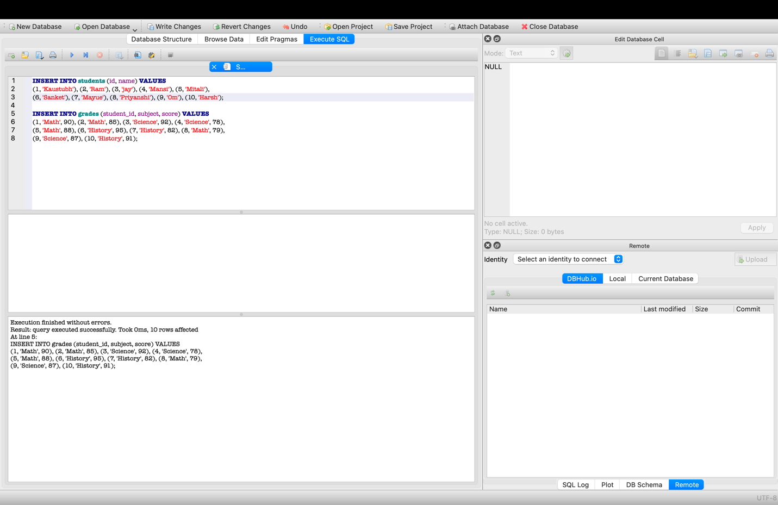

2: Viewing the Full, Populated Table
SQL Query:

SELECT * FROM students;

RESULT:

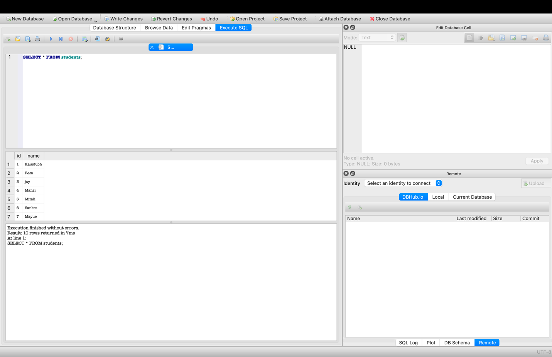

3: Filtering and Sorting Data with a JOIN

SQL Query:
SELECT name, score
FROM students
JOIN grades ON students.id = grades.student_id
WHERE score > 85
ORDER BY score DESC;

Result:

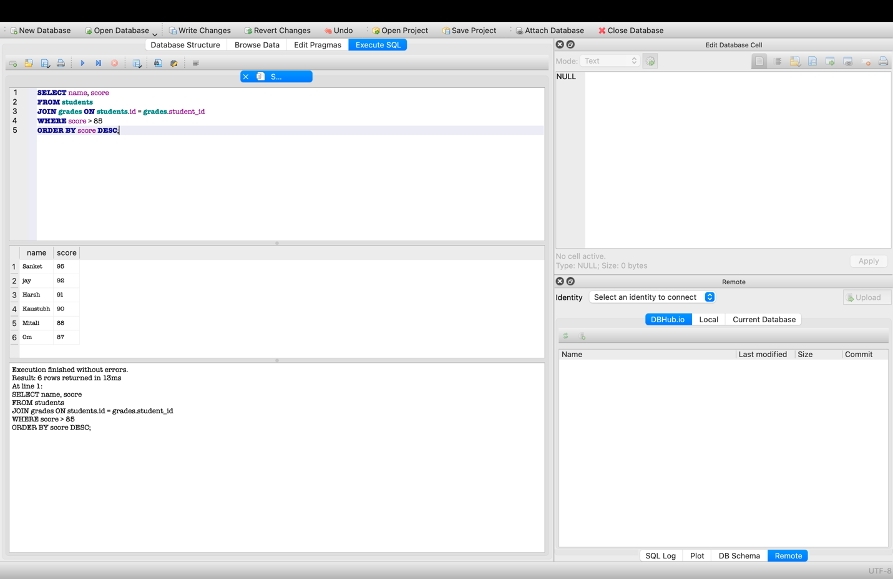

4: The "Aggregated Performance" Query

SQL Query:
SELECT students.name, grades.subject, grades.score
FROM students
JOIN grades ON students.id = grades.student_id
WHERE grades.score > 85
ORDER BY grades.score DESC;

Result:

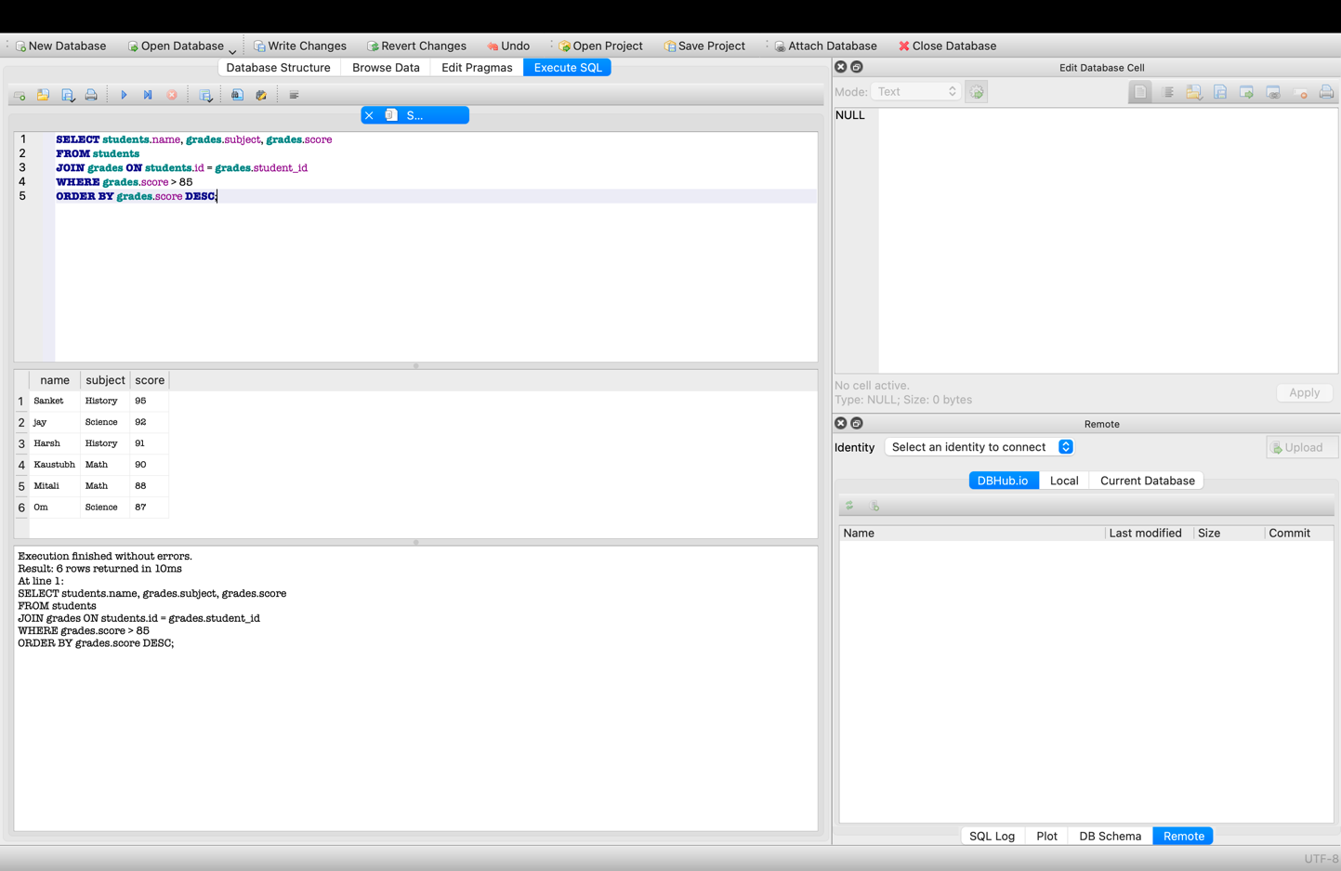

5: The "Subject Grouping" Query
SQL Query:
SELECT subject, COUNT(student_id) AS student_count
FROM grades
GROUP BY subject
HAVING COUNT(student_id) > 2;

Result:

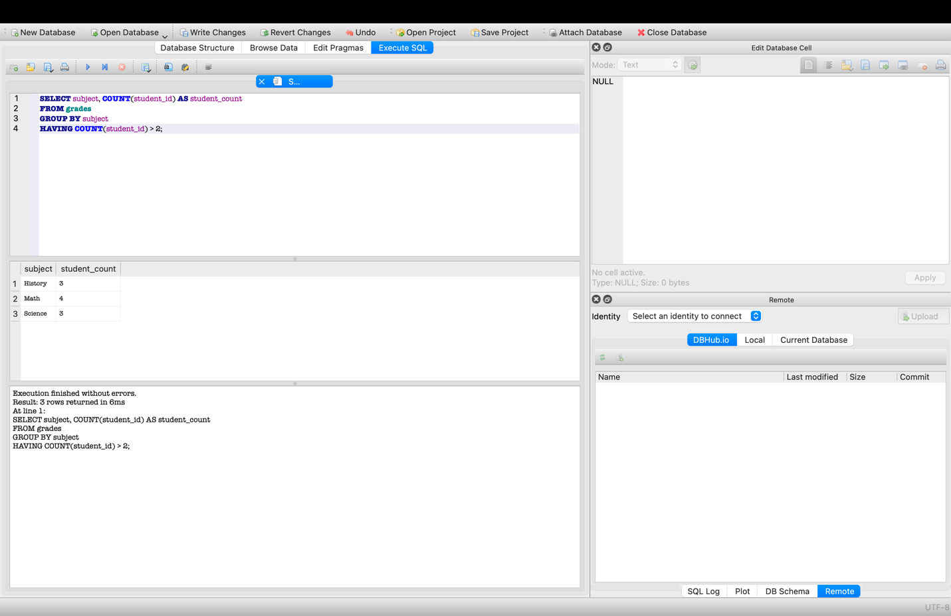
References:
Silberschatz, A., Korth, H. F., & Sudarshan, S. (2020). Database System Concepts (7th ed.). McGraw-Hill Education.
Pratt, P. J., & Last, M. Z. (2019). A Guide to SQL (10th ed.). Cengage Learning.

README: Project Summary

Overview: This assignment demonstrates how to manage relational databases using SQLite. It covers creating table structures, inserting student records, and performing data analysis.

Key Features:
- Data Organization: Used Primary and Foreign keys to link student names with their grades.
- Query Skills: Demonstrated ability to filter data, join multiple tables, and group information for reporting.

How to Run: Open the hello.sqbpro file in DB Browser for SQLite to view the database schema and re-run any of the queries shown in this report.

